SIMATS ENGINEERING
Saveetha Institute of Medical and Technical Sciences
Chennai-602105
Name of the student: K. Hemakshitha
Register number:192425088
Course code and name: MLA0104- Artificial Intelligence and Expert Systems
Project title: AI-Powered Student Assistance Chatbot using Dialogflow

Introduction
AI-Powered Student Assistance Chatbot using Dialogflow is an intelligent virtual assistant designed to help students by answering their academic and administrative queries. The chatbot is developed using Google Dialogflow, which provides natural language processing (NLP) capabilities to understand and respond to user questions in a conversational manner.
The system can provide information such as course details, class schedules, examination dates, assignment reduces the need for students to wait for manual support and improves communication between students and the institution.This project demonstrates the application of Artificial Intelligence and conversational technology in the education domain, making student support services more efficient, accessible, and user-friendly.
Problem Statement
Students often have questions related to:
- Course registration
- Timetable
- Attendance
- Examination schedules
- Campus services
Getting these answers from the administration can take time. An AI chatbot provides instant responses, improving efficiency and reducing staff workload.
Objective
- Provide instant responses to student queries.
- Reduce administrative workload.
- Improve communication between students and the institution.
- Be available 24×7.

EXISTING SYSTEM
In the existing system, students usually contact faculty members or administrative staff to obtain academic information. This manual process requires significant time and effort and may result in delayed responses, especially during admission and examination periods. The lack of a centralized automated support system affects communication efficiency and student satisfaction.

PROPOSED SYSTEM
The proposed system is an AI-Based Student Support Assistant developed using Google Dialogflow. The chatbot understands user queries using intents and entities and provides appropriate responses related to registration, attendance, timetables, examinations, and campus services. The system offers 24×7 support and improves communication by providing instant information.
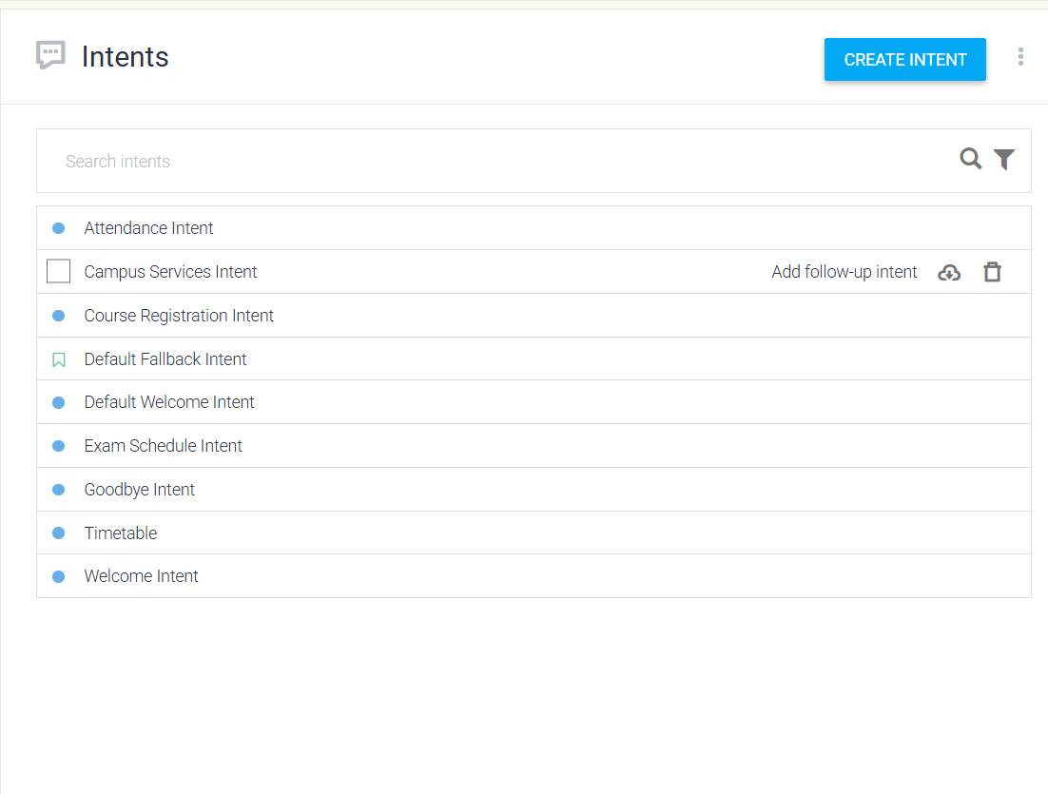

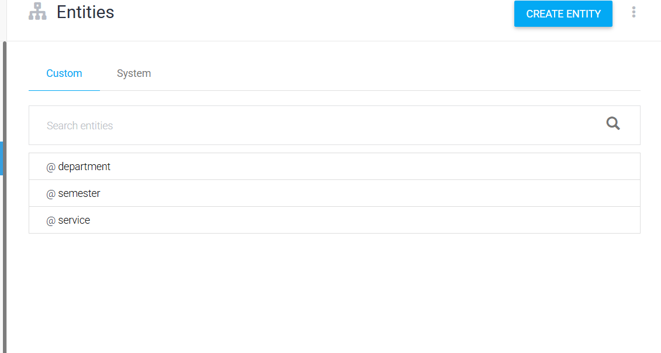

Scope of the Project
The scope of this project includes developing a chatbot that handles common student queries related to academic activities and campus services. The chatbot provides information about course registration, attendance, class schedules, examination timetables, library services, and hostel facilities.
The project is limited to predefined intents and responses developed using Google Dialogflow. In the future, the chatbot can be integrated with the college ERP system to provide personalized student information and advanced features such as voice interaction and multilingual support.

Agent Design
The Student Support Assistant functions as an intelligent software agent that receives user queries and identifies the user's intent using Natural Language Processing techniques. Based on the identified intent, the chatbot provides appropriate responses to the user. This enables smooth and efficient communication.
The agent is developed using Dialogflow components such as intents, entities, and training phrases. Different user expressions are mapped to the same intent, allowing the chatbot to recognize various ways of asking similar questions. This improves response accuracy and enhances the user experience.

Dialogflow Development
Google Dialogflow is used to build the chatbot because it provides powerful Natural Language Understanding capabilities and an easy-to-use interface. It enables developers to create conversational agents without requiring advanced programming knowledge. Dialogflow automatically matches user queries with the most suitable intent.
The chatbot consists of several intents, including Welcome, Registration, Timetable, Attendance, Examination Schedule, Campus Services, and Goodbye. Entities such as Department, Semester, and Service are also created to recognize specific information provided by users. These components help the chatbot generate meaningful and accurate responses.
Conversation Flow
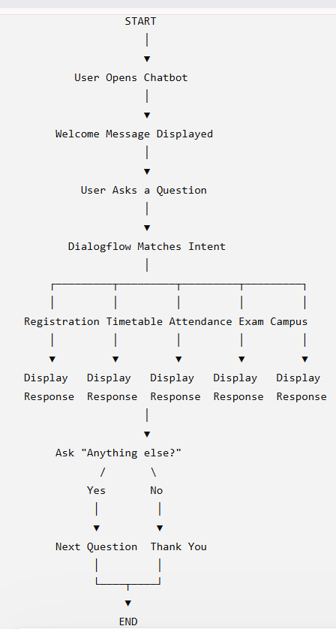

Search Strategy
Breadth-First Search (BFS) is selected as the search strategy for this project to explain the process of intent selection. BFS systematically checks all possible options at the current level before moving to the next level. This concept helps illustrate how the chatbot identifies the most suitable intent for a user query.
Although Google Dialogflow internally uses advanced Natural Language Understanding algorithms instead of BFS, the search strategy is included in the report to satisfy the academic requirements of the project. It provides a clear understanding of how AI search concepts can be related to conversational systems.

Testing and Evaluation
The chatbot is tested with various user queries related to registration, attendance, timetable, examination schedules, and campus services. Each test verifies whether the chatbot correctly recognizes the user's intent and provides the expected response. The testing process helps identify and correct any errors.
The evaluation results show that the chatbot responds accurately to the predefined queries and provides information within a short response time. The system performs efficiently under normal conditions and successfully demonstrates the practical application of conversational AI in educational institutions.
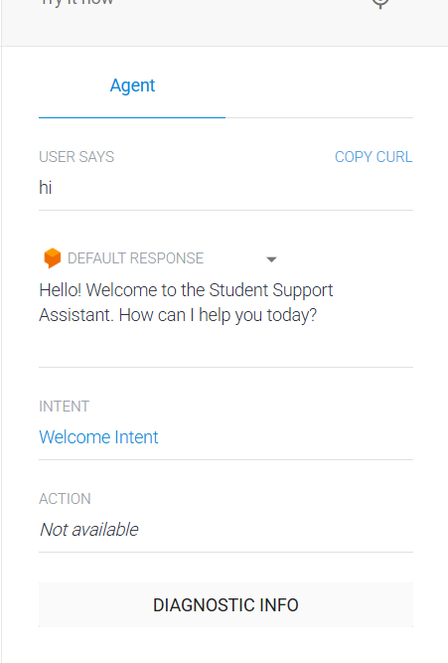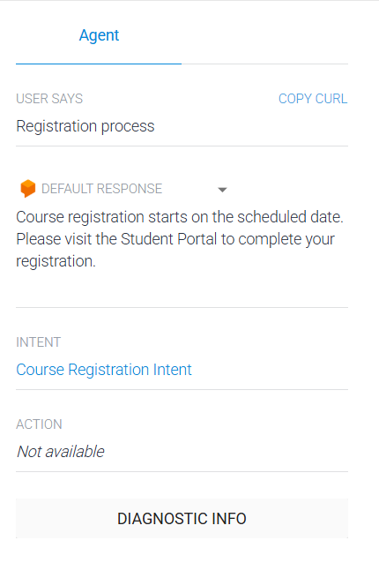
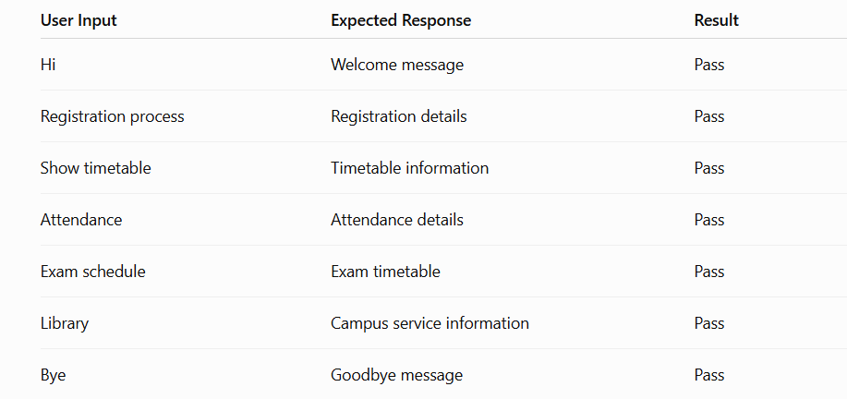

Advantages
The proposed chatbot provides instant responses to student queries, reducing the need for manual support. It is available throughout the day and helps students obtain information quickly without waiting for faculty or administrative staff. This improves accessibility and user satisfaction.
The chatbot also reduces repetitive work for administrative departments and ensures that students receive consistent information. Its user-friendly interface makes it easy to interact with, and the system can be expanded with additional features in the future.

Limitations
The chatbot can respond only to the queries that are included in its predefined intents and training phrases. It cannot answer questions outside its knowledge base unless new intents are added. Regular updates are required to keep the information accurate.
The system also depends on an internet connection and does not provide personalized academic information unless integrated with institutional databases. Therefore, its functionality is limited to the information available during development.

Future Scope
The chatbot can be enhanced by integrating it with the college ERP system to provide personalized information such as attendance, examination results, fee details, and internal marks. This will make the system more useful for students and improve its functionality.
Future versions of the chatbot may also include voice recognition, multilingual support, mobile application integration, and advanced Artificial Intelligence techniques. These improvements will provide a more interactive and intelligent user experience.

Conclusion
The AI-Based Student Support Assistant successfully demonstrates how Artificial Intelligence can improve student support services in educational institutions. The chatbot provides quick, accurate, and reliable responses to common academic queries using Google Dialogflow and Natural Language Processing techniques.
The project reduces administrative workload, improves communication, and enhances the overall student experience. It also demonstrates the practical application of AI concepts such as conversational agents, intent recognition, and search strategies, making it a valuable solution for modern educational environments.

